# CS 340 Project Two README - Mark McCormack

## About the Project/Project Title

**Python CRUD module for working with MongoDB.**

This project contains a python CRUD module that can be used to create, read, update, and delete documents in a MongoDB NoSQL database collection.

## Motivation

The reason this project exists is to introduce and learn about the power and capabilities of using python modules in conjunction with a NoSQL database like MongoDB. We chose PyMongo as our driver for many reasons:

* Pythonic API - This means that PyMongo works seamlessly between Python and MongoDB which makes working with it feel natural.
* Performance - PyMongo is optimized for performance specifically as it relates to MongoDB database operations.
* Flexibility - MongoDB is known for it’s flexibility in working with non-traditional data structures and PyMongo helps us take advantage of that by allowing operations to affect the database without rigid data structures.
* Cross-Platform - PyMongo can be used on many different kinds of OS which allows developers more freedom of choice regarding their environment.

**Required Functionality:**

This project has been developed to perform CRUD operations on unstructured local area rescue animal data using a Plotly Dash app to display real time updates to the client. The following screenshots demonstrate the applications functionality.

Screenshots of logo, unique identifier, and starting state of dashboard. You can see that the entire data set is retrieved when the dashboard starts up with the “Reset” filter option radio button selected. 1/2

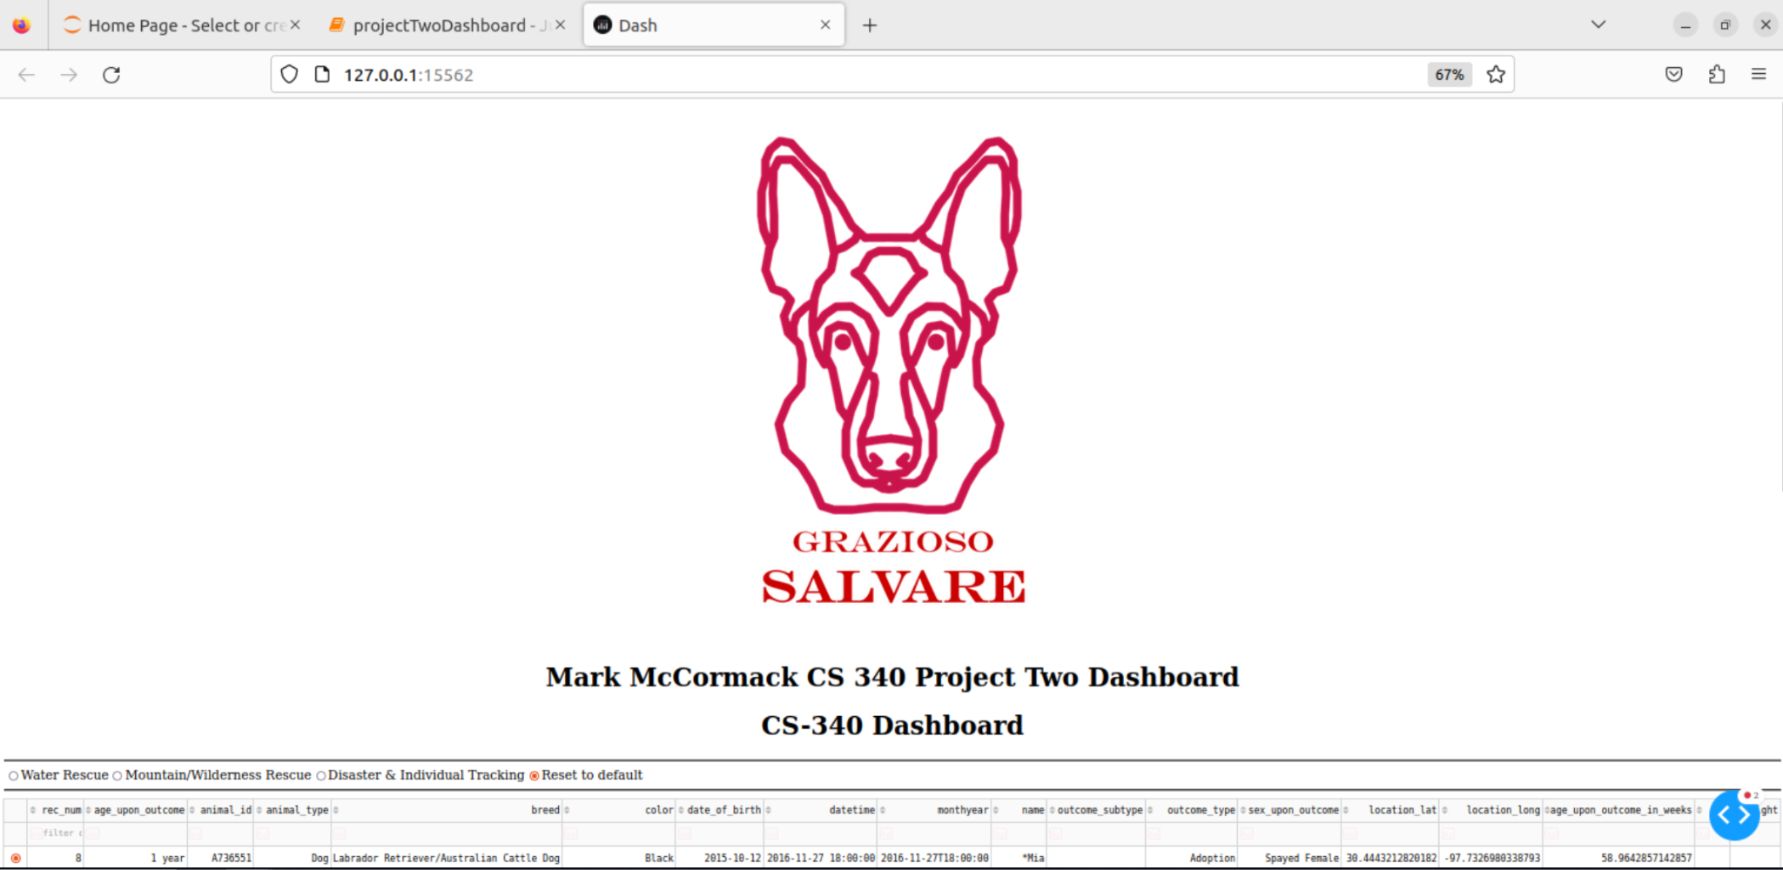

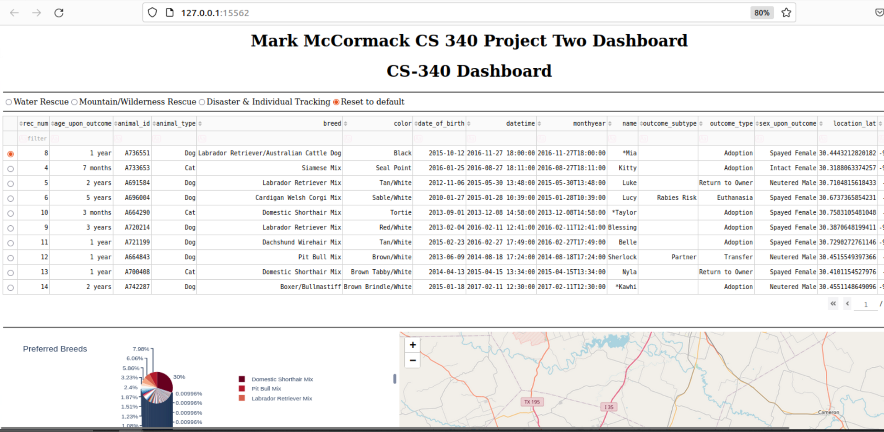

2/2

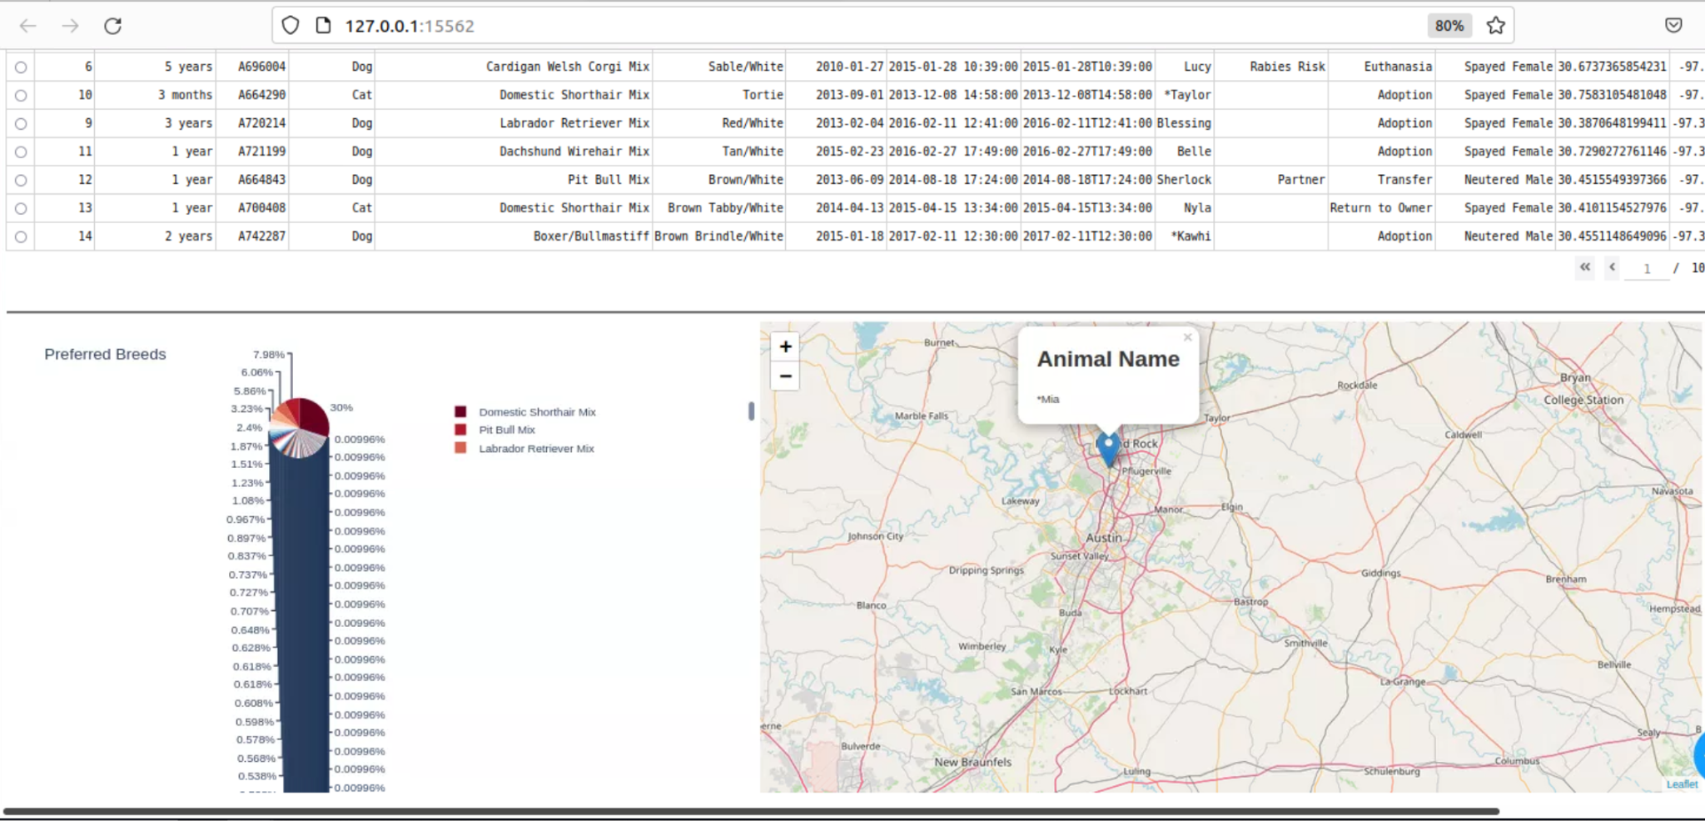

Screenshots of dashboard execution when filter options are applied via the radio buttons above the data table - Disaster Rescue filter option:

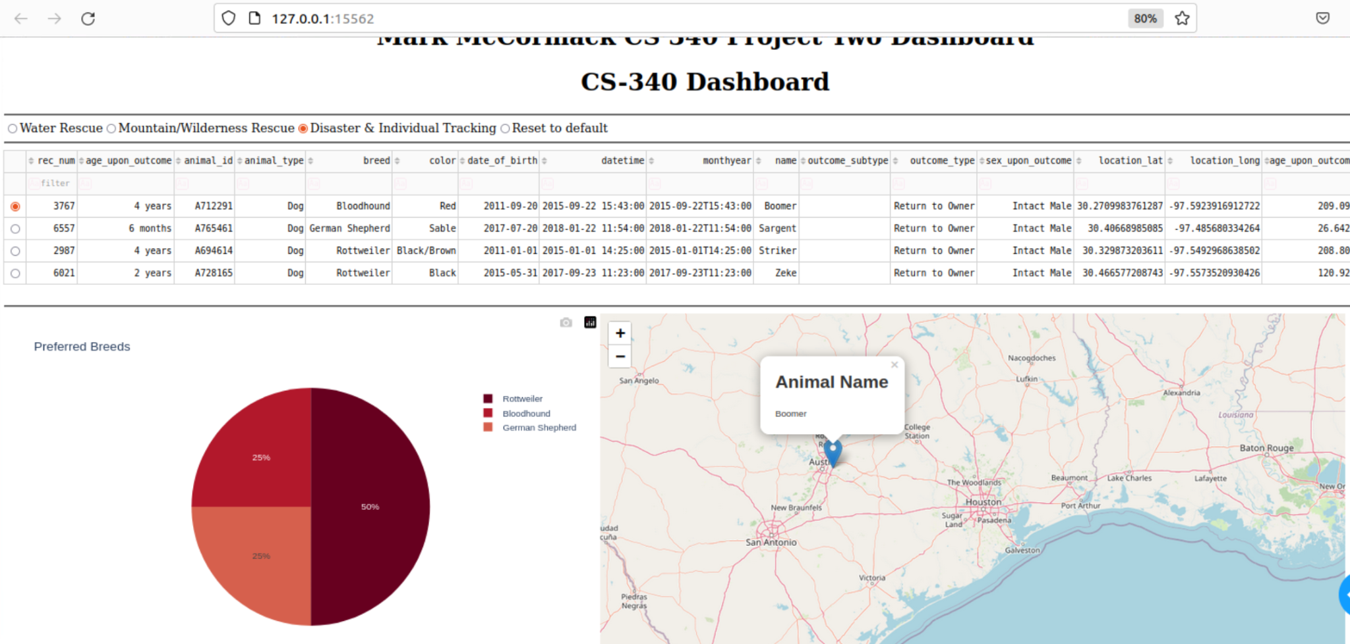

Mountain & Wilderness Rescue filter option:

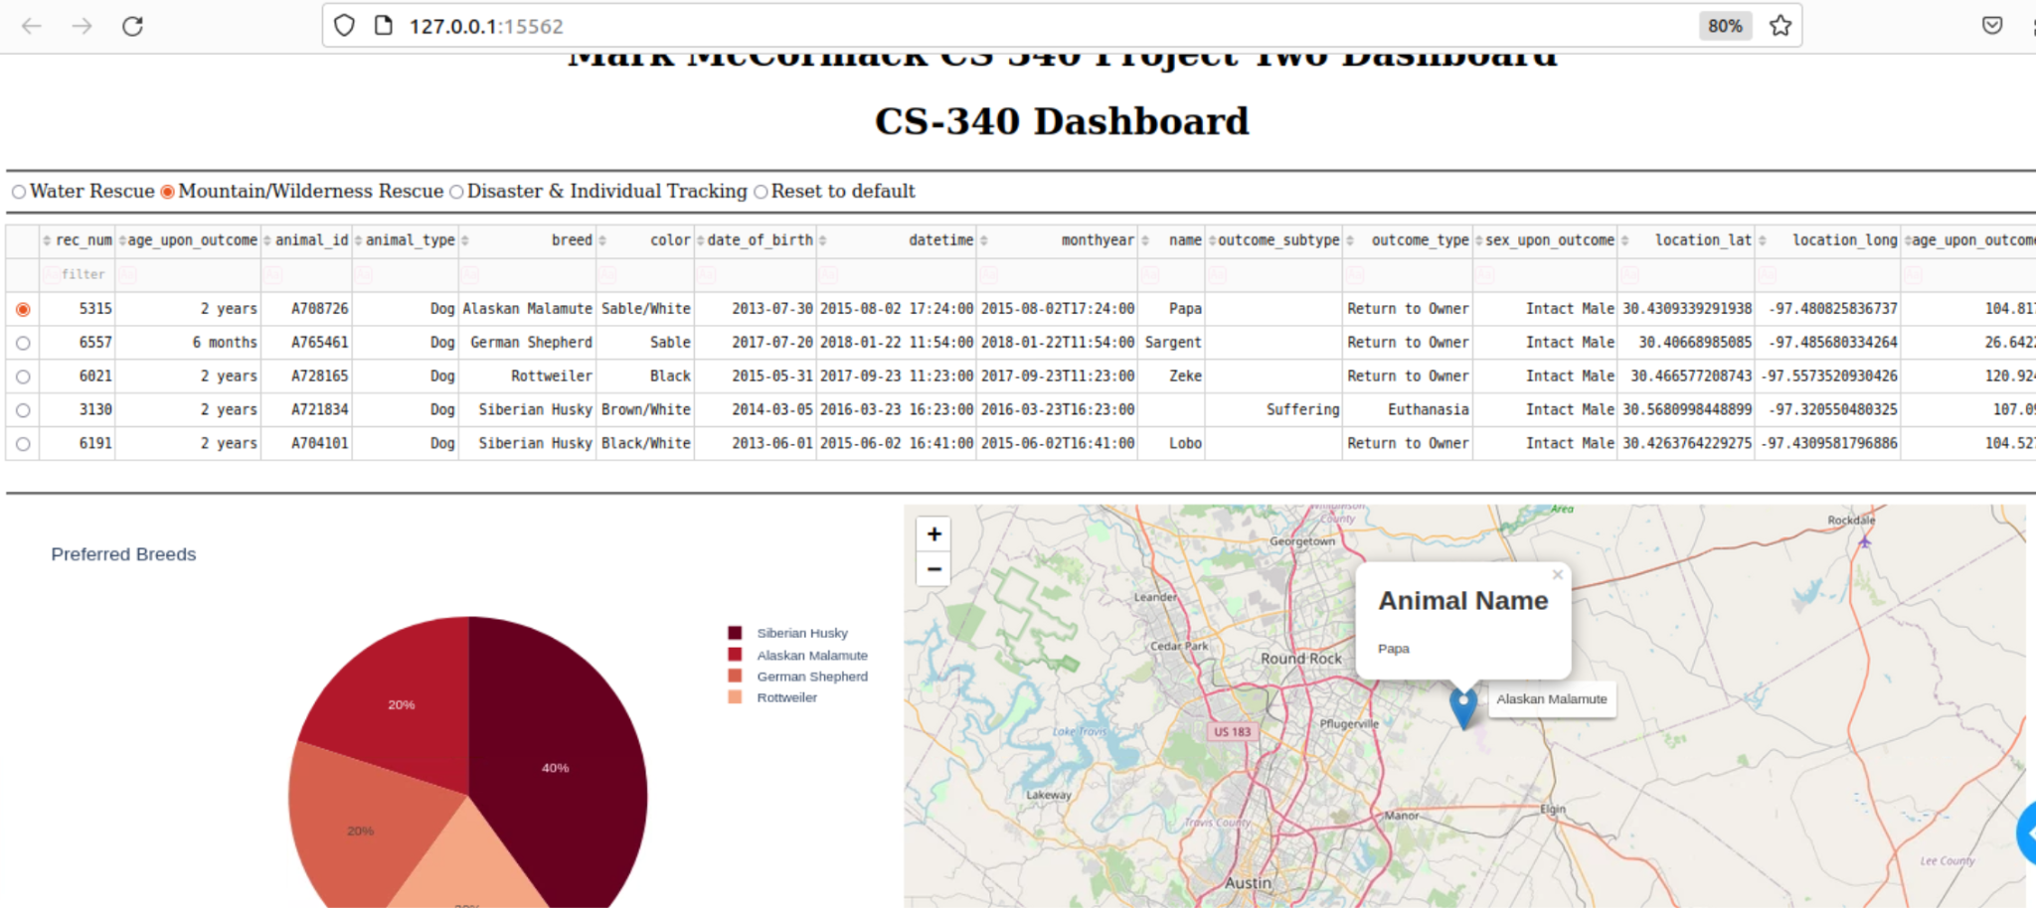

Water Rescue filter option 1/2:

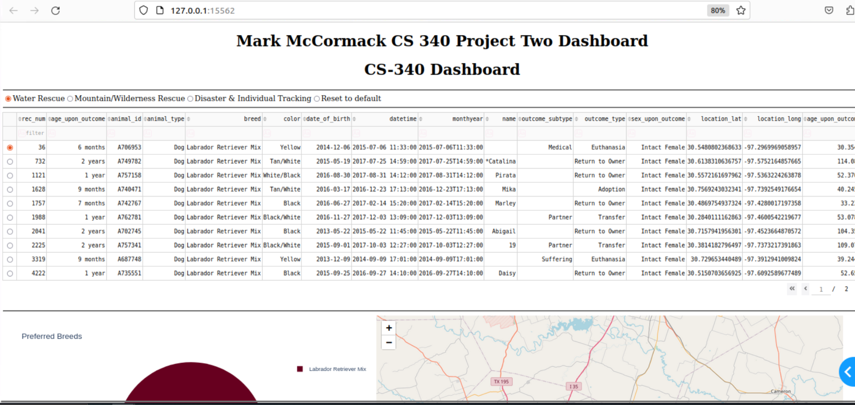

Water Rescue filter option 2/2:

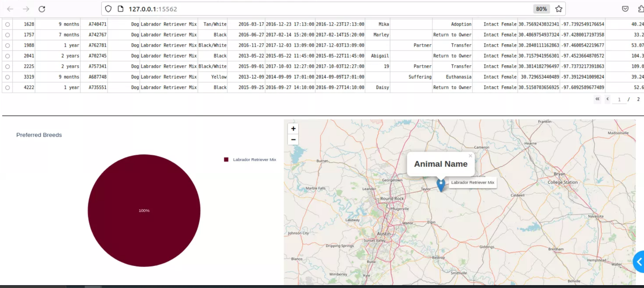

**Components, Tools & Rationale**

The primary components in this application are Python, MongoDB, and Plotly Dash.

* Python was chosen for its high powered capabilities related to our data driven web development use case.
* MongoDB was chosen for its flexibility in handling unstructured data and because MongoDB stores data in binary JSON format, referred to as BSON. Python stores data natively as dictionaries which is similar to BSON. The PyMongo driver allows for seamless integration between MongoDB and Python. Another reason for choosing MongoDB is performance. Mongo has very high performance in workloads that experience large amounts of read requests which works well for our use case because the Dash App needs to be able to quickly retrieve all the records at start up and during operation. MongoDB supports geospatial capabilities along with real time data processing which perfectly matches our use case.
* Plotly Dash is a web application framework for python that provides both the view and controller structure for the application which allows callbacks to update the various widgets in real time. Dash is great for dashboards and data visualization which is ideal for our use case because users are meant to search through the database using the various dashboard filtering options that have been programmed. The client can use these visualizations to find promising rescue animal candidates.

## Getting Started

To try this code out for yourself see the following:

1. Initialize your MongoDB instance and import the AAC database for use.
2. This project includes hard coded environment variables that need to be changed to the relevant information for your database on lines 10 - 17 such as user, password, database host & port, as well as the database and collection you want the module to use. These values are unique to your environment.
3. Now you can use a Jupyter Notebook to run some tests with the module, just make sure the .ipynb and .py module files are in the same directory within the file system so the Notebook can import the python module.

## Installation

Tools you’ll need to make sure are installed and configured include:

* Python 3 - Follow this [python3](https://realpython.com/installing-python/) guide depending on your workstation OS type.
* MongoDB - Follow this [MongoDB](https://www.mongodb.com/docs/manual/installation/) guide according to your OS type.
* pymongo - Check out the [official MongoDB](https://www.mongodb.com/docs/drivers/pymongo/) to learn more about the pymongo driver and how to install it.
* Jupyter Notebook, or your preferred IDE. VS Code has great python and Jupyter plugins.

## Documenting the Project:

**Import the database**

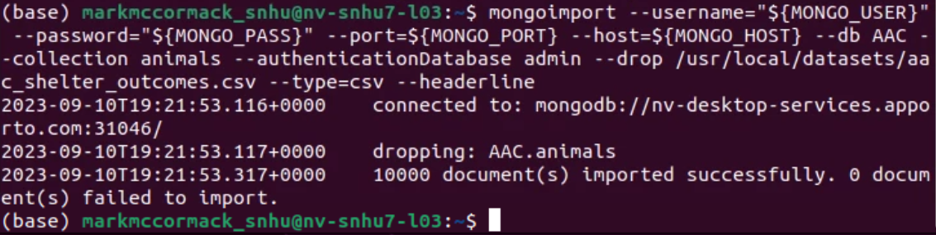

**User Creation & Authentication**

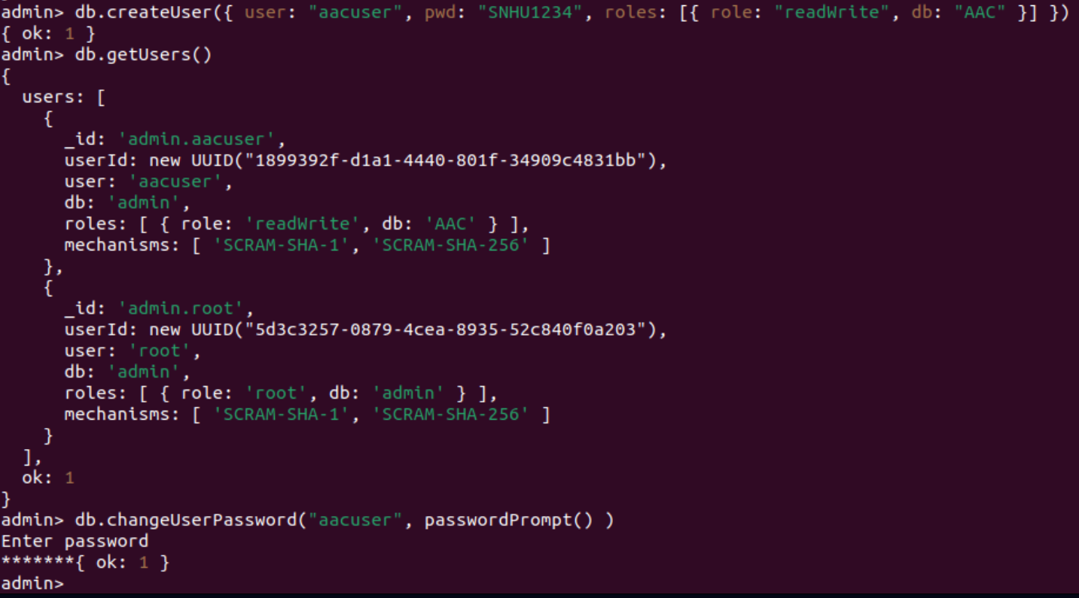

**Code Example**

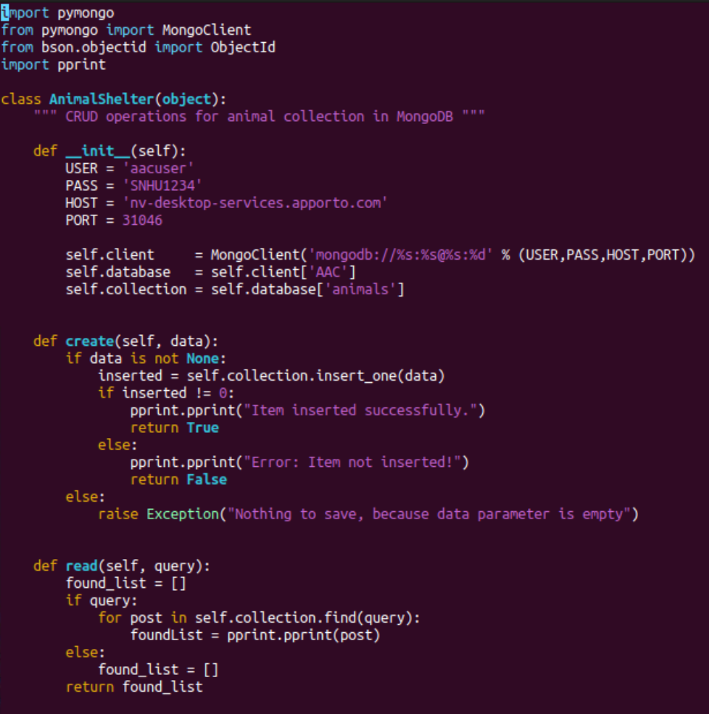Above are the Create and Read functions of the python CRUD module along with the initialization function which sets environment variables for connecting to the database.

The **create** function takes data as input and then inserts the new information into the database, else print an error message.

The **read** function is built to return all documents that contain the matching key/value pair provided in the query input and return it in a list, else return an empty list.

Next is the Update and Delete functions of the python CRUD module.

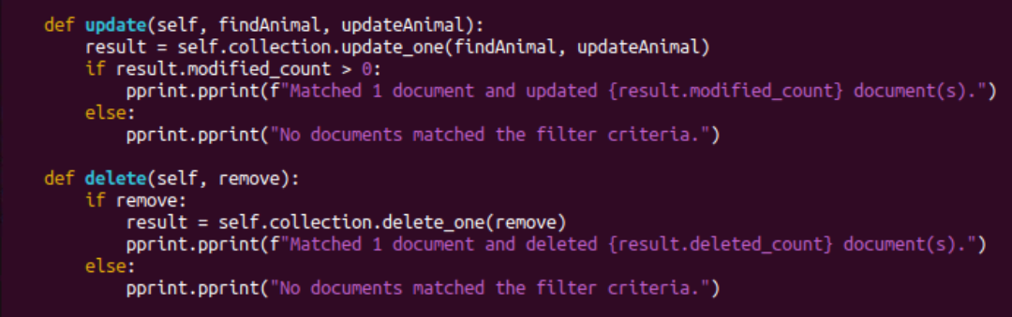

The **update** function takes 2 inputs, the key/value pair (findAnimal) to find the document(s) that match, and the key/value pair (updateAnimal) which represents the data you want to add or update. If the update function finds what it’s looking for then it sets the specified value, prints a message to let the user know what’s been done, else if not found print a none found message.

The **delete** function takes as input a key/value pair to find the document you’re looking for and delete it if found, else print a none found statement.

### Tests

Below is an example of a document insertion test using Jupyter Notebook to call the create function of the CRUD module to insert a new document into the database. This code also tests the read function by passing a query to it.

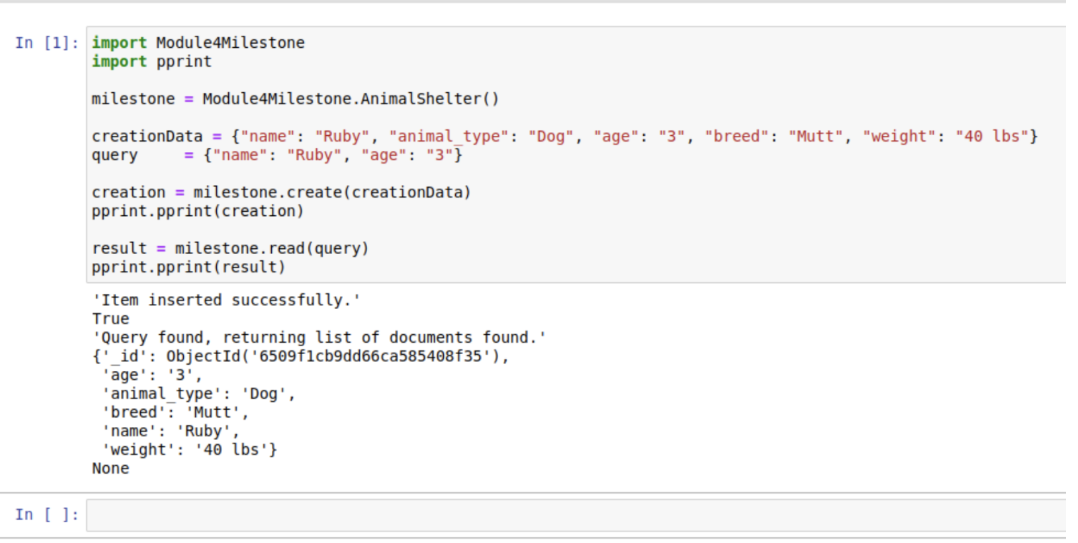

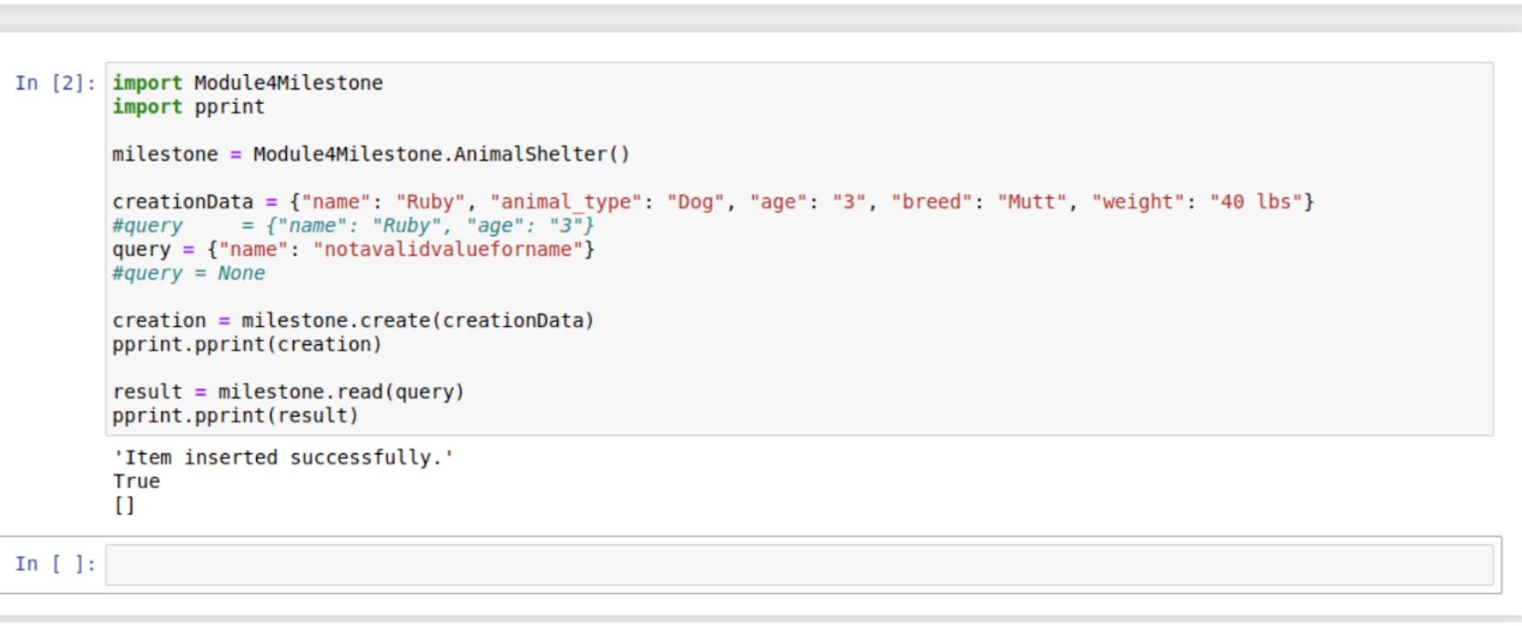This is an example of how to return an empty list if no documents in the animals collection contain the key/value pairs in the query string, or if the query variable is None.

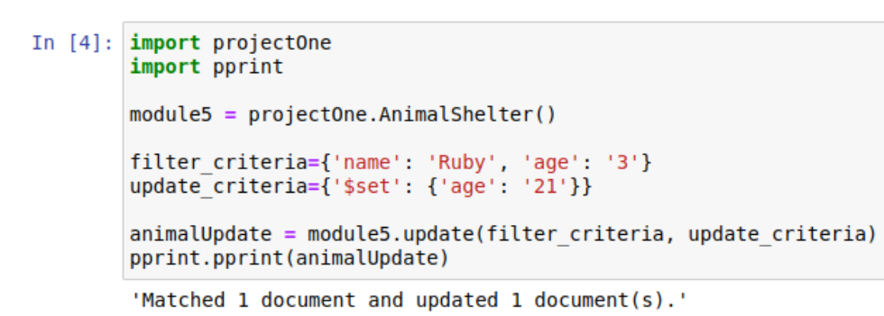

Notebook test showing successful update of existing document within the collection.

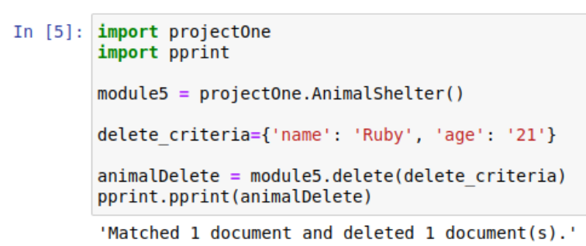

Notebook test showing successful delete operation on a document in the animals collection.

## Contact

Mark McCormack

email: mark.mccormack@snhu.edu